One of my project is an Medical Insurance Cost Prediction System
“Insurance companies calculate medical insurance premium using different traditional techniques which can inefficient
So I have built a Medical Insurance Cost Prediction system which is a machine learning model that can predict insurance costs automatically and accurately.”
It predicts insurance charges based on factors like age, BMI, smoking habits, gender, region, and number of children.”

“First, I loaded the dataset using Pandas and performed data-preprocessing.During Data-Preprocessing,
I have converted categorical columns into numerical form using Label Encoding.”
After Data-Preprocessing,
I have divided the dataset into training and testing sets using Train-Test Split
Then I have used 3 algorithms which are Linear Regression,Random Forest and trained them on the dataset
After that, I have used evaluation metrics to compare the performance of all these three algorithms
In evaluation metrics,I have used:
- R² Score
- MAE
- RMSE

After comparing all models, Random Forest produced the best balance between R² score and error met, so I selected it as the final model and developed the Model.
I have finally integrated streamlit into the project for interactive frontend
Finally,I deployed my project using Streamlit Community Cloud
insurance.csv
↓
Pandas DataFrame
↓
Preprocessing
↓
Label Encoding
↓
Feature / Target
Separation
↓
Train-Test Split
80 / 20
↓
┌────────────┼────────────┐
↓ ↓ ↓
Linear Regression Random Forest
↓ ↓ ↓
└────────────┼────────────┘
↓
Model Evaluation
R² / MAE / RMSE
↓
Random Forest
Final Model
↓
Streamlit UI
↓
User enters data
↓
Preprocessing
↓
Random Forest
↓
Predicted Insurance Cost

Input Variables(Features)->age,sex,bmi,smoker,children,region
Output Variable(Target)->Charges

Technique | Purpose
Label Encoding | Convert text to numbers
One Hot Encoding | Better categorical encoding
Scaling | Normalize values
Missing Value Handling | Fill empty data
Feature Selection | Choose important columns
Outlier Removal | Remove abnormal values

5. Explain preprocessing
sex → male / female
smoker → yes / no
region → northeast / northwest / southeast / southwest

I used LabelEncoder()
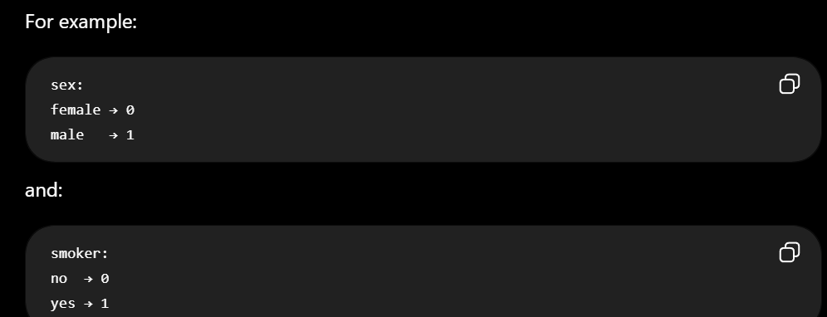
"For binary categorical variables such as sex and smoker, label encoding is straightforward because there are only two categories. For region, which has four categories, one-hot encoding could also be considered because the numerical values

14. What challenges did you face?
Another challenge was determining which regression algorithm would perform best, so I trained multiple models and compared them using R², MAE and RMSE."

16. What did you learn?
Say:
"Through this project, I learned the complete machine learning pipeline

4. How can you reduce overfitting?
• Use cross-validation
• Remove irrelevant/noisy features

What is Streamlit?
1. streamlit
Streamlit is a python-library Used to create web apps and dashboards using Python.

2. Why didn't you use Flask or FastAPI?
"Flask and FastAPI are excellent choices, especially when building a backend API that needs to communicate with a separate frontend. For my project, I wanted a simple ML demonstration with an interactive UI, so Streamlit was sufficient

5. What is requirements.txt and why is it required for deployment?
Your project notes explicitly mention:
pip freeze > requirements.txt
requirements.txt is a file containing the Python packages and their versions/dependencies required by your project.
The deployment platform reads requirements.txt and installs the dependencies required to run your application.

How you deploy your project on streamlit cloud?
Typical deployment flow you can explain:
- Developed project in Python + Streamlit
- Uploaded code to GitHub
- Connected GitHub repository to Streamlit Cloud
- Deployed the application online for public access

STAR Situation
Situation
9. Explain Challenges Faced
Interviewers love this.
Say:
“One challenge was handling categorical data because ML models require numerical input.
Another challenge was comparing multiple models and selecting the best-performing algorithm.”

10. Explain Future Improvements
Say:
“In future, I can improve the project by:
- Using larger healthcare datasets
- Adding user authentication and database storage”

2. Why did you choose this project?
“I chose this project to understand the complete machine learning workflow from data preprocessing to deployment. It also helped me learn regression algorithms and model evaluation.”
24. Explain prediction workflow.
“User inputs details like age, BMI, smoker status, etc.
The data is preprocessed using label encoding, passed to the trained Random Forest model, and the predicted insurance cost is displayed in Streamlit.”
27. What did you learn from this project?
“I learned the complete machine learning pipeline including preprocessing, EDA, regression algorithms, evaluation metrics, and deployment using Streamlit.”

